Environment Act (Wales) 2016 - Part 1, Section 16
Responsibility for Biodiversity and Resilient Ecosystems

Biodiversity and resilience of ecosystems Policy & Report -
Llangynfelyn Community Council

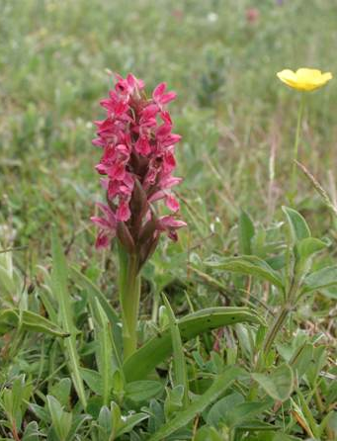
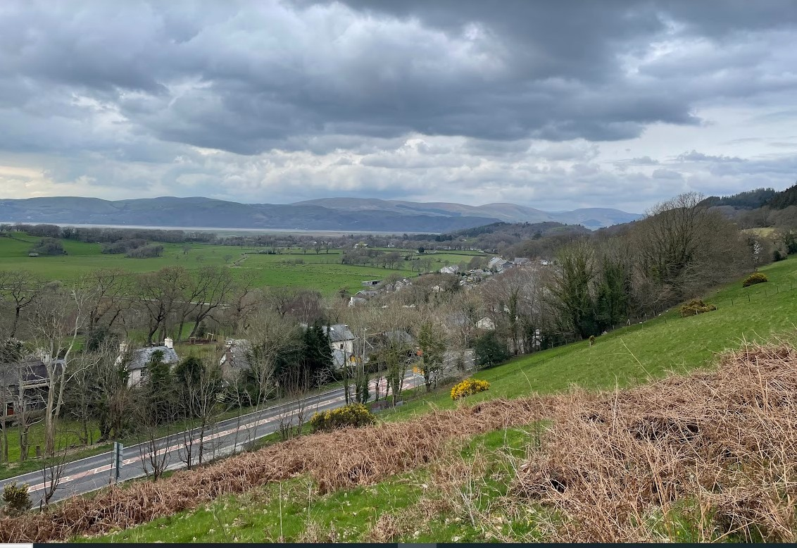

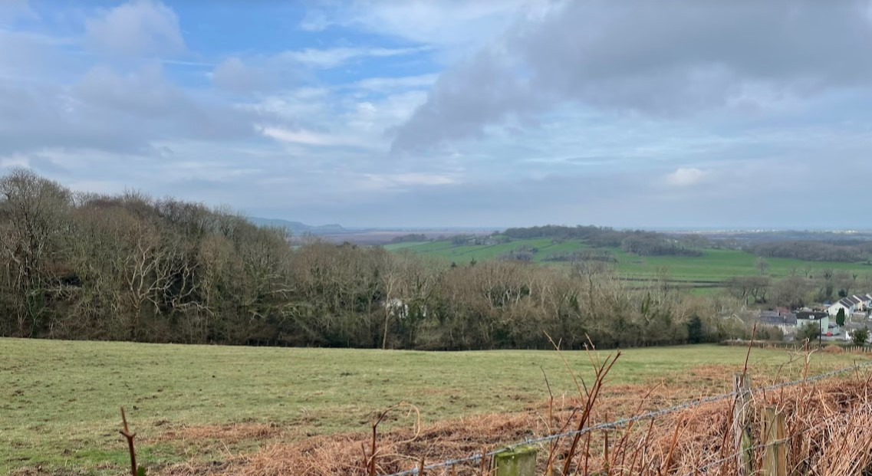
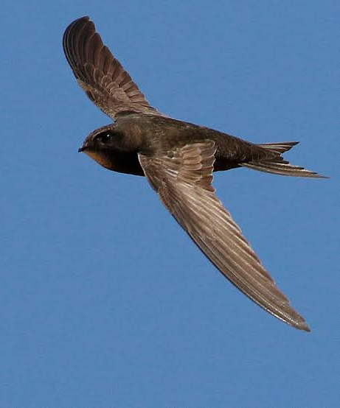
Introduction & Context
Local authorities are split into three groups based on land management responsibility of the authority and its connection with biodiversity. Llangynfelyn Community Council is part of Group 2 - those whose functions include land management and with influence over land owners and/or managers. This policy and report has been prepared in line with the Welsh Government's reporting guidance as available on the Welsh Government's website.

“Public authorities must seek to maintain and enhance biodiversity in the exercise of functions in relation to Wales, and in so doing promote the resilience of ecosystems, so far as consistent with the proper exercise of those functions.”
NRW’s State of Natural Resources report shows that we are losing habitats and species in Wales.

The council must prepare and publish a plan setting out what it proposes to do to comply with the duty.

It can include:
- How biodiversity will be incorporated into policies and strategies;
- What initiatives will be introduced to raise awareness within your organisation;
- What practical biodiversity programmes will be introduced;
- What partnerships will be developed.
A public authority must, before the end of 2019, and before the end of every third year after 2019, publish a report on what it has done to comply with the duty.

The Duty to Maintain and Enhance Biodiversity
Further detailed information in the Nature Recovery Action Plan for Wales (NRAP) to contribute to reversing the decline of biodiversity in Wales:
- Embed biodiversity into delivery, and raise awareness of its importance
Commitments, Sustainability and procurement policies, management plans, community engagement, awareness raising
- Safeguard special sites and species and improve their management
Local nature sites, protected species e.g. bats, great crested newts, birds
- Restore and create habitats
Churchyards, play-spaces, village greens
- Tackle key pressures like pollution, and Invasive Non Native species
Himalayan balsam bashing, reducing the use of pesticides
- Use and collect biodiversity evidence
Citizen science, Local Environment Record Centres

The Council should be raising awareness of the importance of biodiversity and embed this value into decision making. For example – a small piece of Local Authority owned woodland may be worth far more for its water retention, air particulate matter filtering, recreation area, mental health benefits, cultural value of birdsong and wildflowers than a financial value.
These benefits should be embedded in decision making to reflect the true value of our biodiversity and green space.

About Llangynfelyn Community Council
The Ward of Llangynfelyn falls within the wider UNESCO Dyfi Biosphere Reserve and within the Mid Wales Area Statement of Natural Resources Wales. Llangynfelyn Community Council represents 587 people. The precept for 2024/25 is £8250.

Llangynfelyn Community Council undertakes a number of services for the local community which have an effect on biodiversity. These include:

Responsibility for green spaces - in particular just over 100 acres of commons which form part of Cors Fochno (Borth Bog). Please see the map provided in Appendices. These spaces form part of the Cors Fochno National Nature Reserve (NNR) and fall within the Site of Special Scientific Interest (SSSI). Cors Fochno is important for a wide range of invertebrates including the:
  - rosy marsh moth
  - large heath butterfly
  - bog bush-cricket
  - small red damselfly
  - bog raft spider
  - Cors Fochno is also home to a range of special plants and other reptiles and bird species such as the Nightjar.

There are also a number of significant oak trees within the boundary of the community council.

Funding - the Community Council provides small grants for projects within the area. These could be awarded to projects improving biodiversity or ensuring no negative effect on biodiversity of the area.

This Policy has been prepared by 2 Councillors on behalf of the wider Council. Councillors will attend additional training provided by One Voice Wales and other bodies to ensure the Council is aware of all responsibilities due under Section 6. This policy will be monitored through councillors reporting to the council all developments and steps taken to deliver this policy on an annual basis, and will be included in the publically available annual report at the councils AGM in May.

This policy also supports the Council’s delivery of the Well-being of Future Generations Act, in particular the goal of a ‘resilient Wales’, with thriving ecosystems.
MAPS
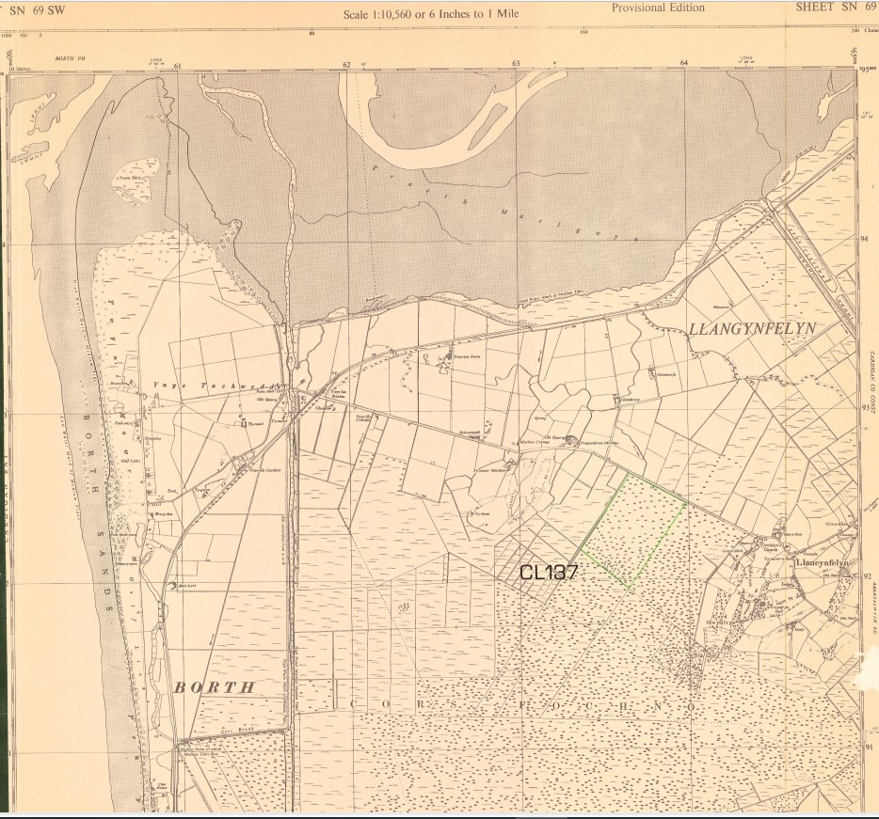
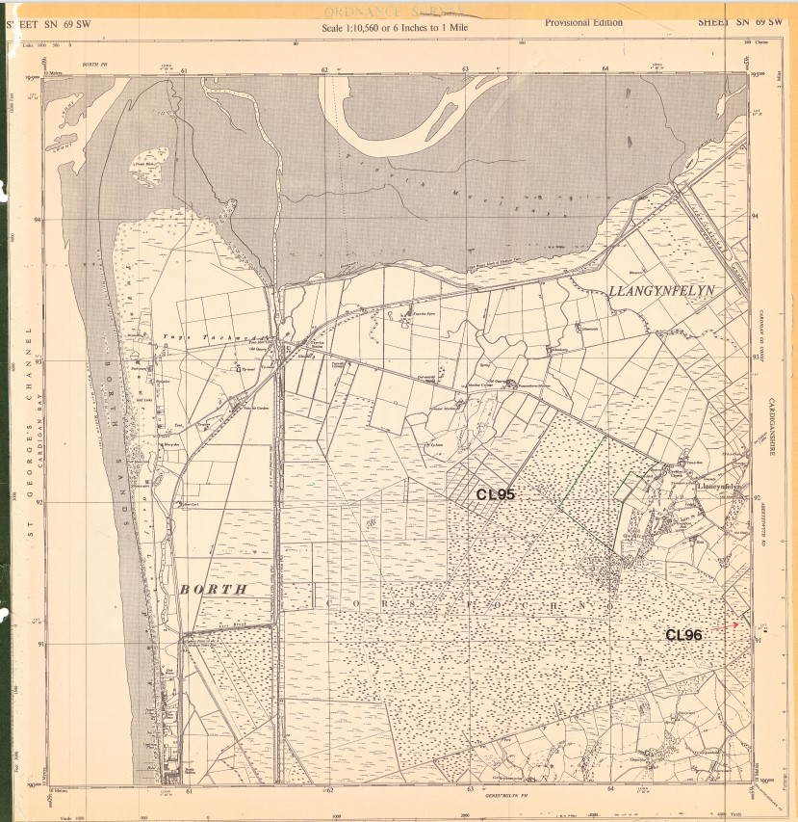
Figure 1 Map Common Land CL137
Figure 2 Map Common Land CL 95

Actions and Reporting (To be reviewed annually)
Aim | Actions | Monitoring
Include biodiversity considerations in our decision-making, funding and procurement processes. | 1.1 Council to include consideration of impact to biodiversity in awarding donations/grants annually, actively seeking to support projects which improve biodiversity
 | 1.2 Council to ask contractors cutting paths/grass to do so in a way which benefits biodiversity
Raising awareness of biodiversity & its importance, to maintain and increase opportunities for health and wellbeing through interaction with biodiversity. | 2.1 Host a biodiversity day where the community can be part of informing and developing this biodiversity policy and plan
 | 2.2 Encourage residents to be part of ‘No Mow May’, committing to not cutting lawns during this time to support pollinators and other invertebrates, bird life and other wildlife
 | 2.3 Seek to advertise public footpaths in the area and the wildlife which might be seen from these. Through posts on the Facebook page, information on the website and in future developing footpath maps.
 | 2.5 Work with the Llanfach Committee and other organisations to host biodiversity raising events
Restore and create habitats and resilient ecological networks | 3 Continue to engage with NRW for improved management of Commons land, in particular the areas connected to Cord Fochno (Borth Bog) and ensure actions taken improve biodiversity.
Protecting key species and habitats | 4.1 Request that CCC do not use pesticides/round up on land within the community/parish
Protecting key species and habitats | 4.2 Consider impact of planning applications on wildlife and habitats when reviewing cases.
Support the capacity of other organisations and encourage the whole community to volunteer to restore create and maintain nature/green spaces | 5 Support groups, volunteers and organisations working in the area to restore and maintain green spaces through including reference to this in the Grant Making Criteria

Accepted: 11th May 2026

Review: 10th May 2027

https://www.gov.wales/section-6-biodiversity-and-resilience-ecosystems-duty-reporting-guidance
https://www.dyfibiosphere.wales/
https://naturalresources.wales/about-us/what-we-do/strategies-and-plans/area-statements/mid-wales-area-statement/?lang=en

